The more information you know about your partner, the safer and more exciting your playtime will be. Remember, communication is the key to all relationships, kinky & vanilla alike!

Below is a long list of KINKY/BDSM activities, don’t be overwhelmed by the list. You may have no idea what some of these things are, and that's OKAY! Some things might seem extreme or even shocking to you. Don’t worry; you NEVER have to do anything you don’t want to do. Sometimes we might only be interested in fantasizing about certain things and not actually doing them in real life. That’s what negotiation is for, to share with your partner what you will, won’t and might, do.

Take your time and answer as honestly and as best you can. Let the list give you new ideas, spur communication and remember, your answers will change over time and depending on what person you are filling this out for. Some words have similar meaning and are left ambiguous, to see what they mean to you. This form can be filled out by the Top/Dominant, bottom/submissive or Switch!

Please put 2-3 answers next to each item:

The first answer should be, if you’ve ever tried that activity before
- Yes = I have participated in this activity before
- No = I have not participated in this activity before

The second answer should be your interest in engaging in that activity on a scale of
0 – 5, NO,?, +, ! or a combination.
- 0 = I have no interest/don’t like this, but would do it to please you.
- 1 = Not very interesting/don’t really enjoy this too much.
- 2 = This is OK,
- 3 = This is nice/fun/interesting
- 4 = I really enjoy/think I’ll enjoy this activity
- 5 = I LOVE THIS/CAN’T WAIT TO TRY THIS
- NO = Hard limit. I will not participate in this activity at all, at this time.
- ? = Unfamiliar with this activity.
- + = I’m scared of this but would possibly like to explore it.
- ! = I’m embarrassed to admit I like this.

Examples:
Flogging: Yes/5 (Have done it before/LOVE IT!)
Biting: No/+ (Have never tried/scared of this but might like to try it)
Tickling: Yes/5+! (Have done this before/love it/scared of it/embarrassed I like it)

The third Answer would be to write any explanations or more information after your answers. Remember, the more information you have the safer/hotter/more fun things will be.

Examples:
Flogging: Yes/5 - I especially love to be flogged on my back!!!
Tickling: Yes/5+! - My feet are my most ticklish place but I didn’t tell you that! <s>

You can download a copy of this form at www.50ShadesofCurious.com/negotiation

Age Play:
Anal Sex:
Arm/Leg Sleeves:
Begging/Pleading:
Being Blindfolded:
Being Gagged:
Bestiality:
Biting:
Body Modifications:
Bondage (heavy):
Bondage (light):
Boot Worship:
Breast bondage:
Breast Whipping:
Breath Play
Brown Showers/Scat:
Caning:
Chauffeuring:
Choking:
Chosen Clothing for:
Chosen Food For:
Clothespins:
Cock Worship:
Collars (wearing):
Corsets (wearing):
Cutting:
Daddy Play:
Double Penetration:
Duct Tape:
Electricity:
Enemas:
Examinations (physical):
Exhibitionism:
Face Slapping:
Fantasy Gang Rape:
Fantasy Rape:
Fire Play:
Fisting:
Flogging (back):
Flogging (butt)
Following Orders:
Foot Worship:
Forced Dressing:
Forced Homosexuality:
Forced Masturbation:
Forced Nudity:
Forced Servitude:
Full Head Hoods:
Gags:
Genital Sex:
Given Away:
Golden Showers (piss play):
Hair Pulling:
Hairbrushes:
Hand Jobs:
Handcuffs (metal):
Harnessing:
Head (getting):
Head (giving):
High Heel Worship:
Homage With Tongue:
Hot Waxing:
Housework:
Human Pony:
Human Puppy:
Humiliation In Private:
Humiliation In Public:
Ice Cubes:
Including Others:
Infantilism:
Interrogations:
Intricate Rope Bondage:
Kicking:
Kidnapping:
Kneeling:
Knives:
Latex:
Leather Restraints:
Lecturing:
Licking:
Massage(getting):
Massage(giving):
Medical Scenes:
Mommy Play:
Mouth Bits:
Mummification (saran wrap:
Needle Play:
Nipple torment:
Oral/Anal Play:
Orgasm Control:
Orgasm Denial:
Over-the-Knee Spanking:
Phone Sex:
Piercing (perm):
Piercing (temp):
Pony Play:
Punching (controlled):
Punching (beat down):
Pussy Whipping:
Pussy Worship:
Religious Scenes:
Riding Crops:
Rope:
Scratching:
Sensory Deprivation:
Serving as Ashtray:
Serving as Furniture:
Serving as Maid:
Serving Orally:
Serving Other:
Sex in Scene:
Sexual Deprivation:
Shaving:
Single Tail (light/sensual):
Single Tail (moderate/heavy)
Spanking:
Speculums (vaginal):
Spreader Bars:
Stocks:
Straight Jacket:
Strap-on Dildos:
Supplying Victims:
Suspension:
Swapping:
Swinging:
Taboo Themes:
Tattooing:
Teasing:
Tickling:
Triple Penetration:
Uniforms:
Verbal Humiliation:
Videoed Scenes:
Voyeurism:
Whipping (cat o’ nine etc.):
Wrestling:

Important Questions:

Physical Concerns - Do you have any medical conditions, chronic or otherwise, that the Top should know about? (Epilepsy, weak shoulders, skin Allergy, etc.) Are you on any prescription medications? Etc.

Mental Concerns - Do you have any phobias or mental conditions that the Top should know about? (Fear of heights, Claustrophobia, etc.)

Limits - Are there any specific scene-related things you will not do?

Fetishes - Are there any specific scene-related things that you really like or dislike? Something that has not been mentioned above:

For more information, education & great kinky toys, please visit us at:

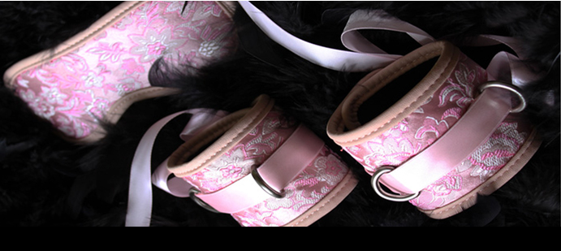
www.50ShadesofCurious.com
info@50ShadesOfCurious.com

